**Example of same technology being used elsewhere**

[Radix Traffic Company Profile / Magnetometer Vehicle Detector](https://www.youtube.com/watch?v=dKk407qnR9s)

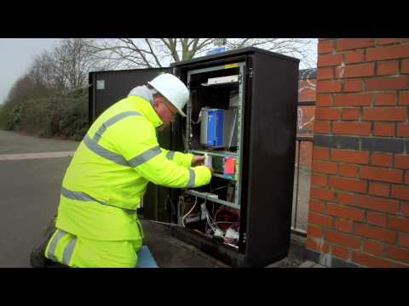

[Vehicle Detection Solutions](https://www.youtube.com/watch?v=7a1fiUJtp_k)

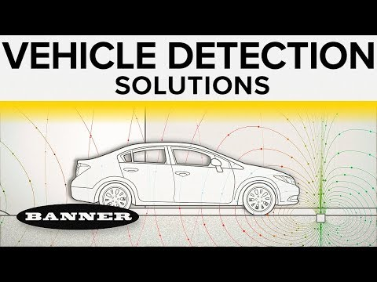

[How magnetometer works? | Working of magnetometer in a smartphone | MEMS inside magnetometer](https://www.youtube.com/watch?v=_ZiLwoClRGQ)

